# Department of Computing

**CS220: Database Systems**

**Lab 08: ER Diagram**

|  |  |
| --- | --- |
| Name | CMS ID |
| Fatima Seemab | 291310 |
| Maryam Fatima | 290479 |

Class: BSCS-9B

# Instructor: Dr. Shams

**Lab Engineer: Ms. Sadia Amir**

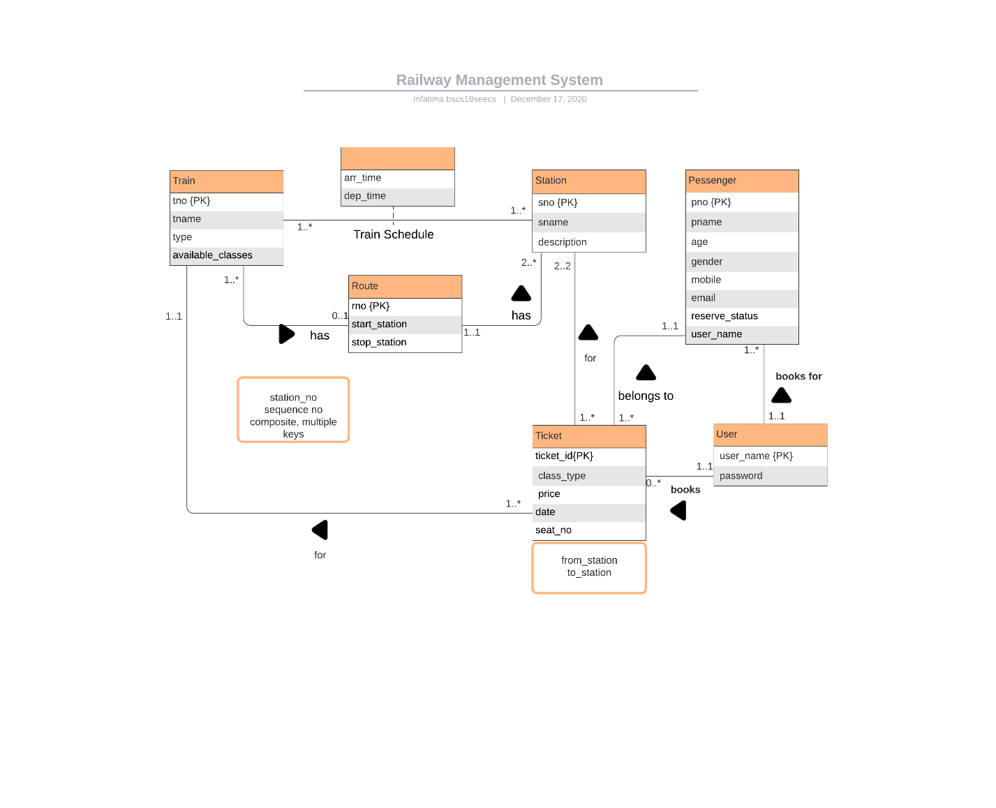

**Explanation**:

User can book multiple tickets and for multiple passengers.

A ticket belongs to only one passenger and is booked by a single user. It is booked for single train and has data of two stations, one is source and other is destination.

A train has a route, which consists of 2 or more stations, each specified with a sequence number.

Multiple trains can travel on a route.

A station belongs to only one route.

Train Schedule is a relationship between Train and Station, contains arrival and departure time of train for each station.